How to Enter Your Picks

First, Select Make Picks

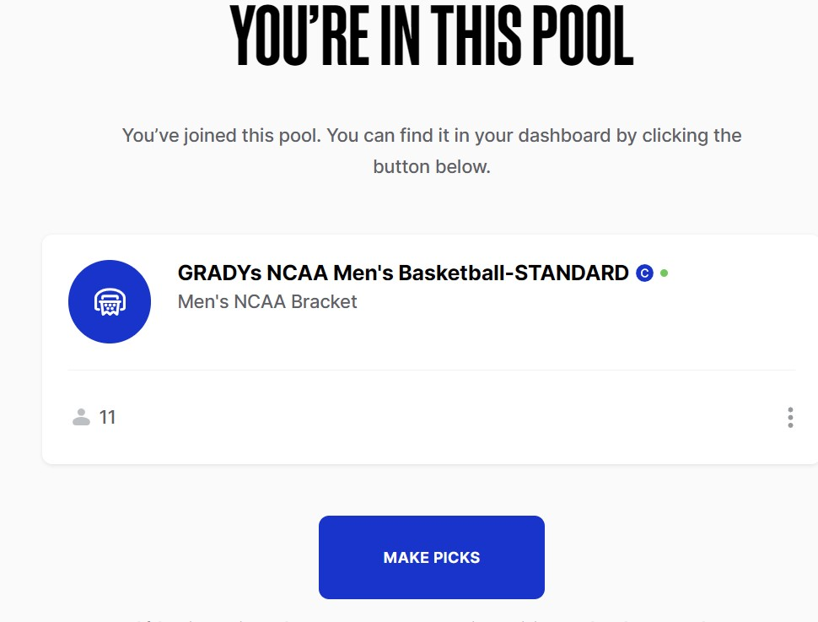

Then SELECT Your Brackets

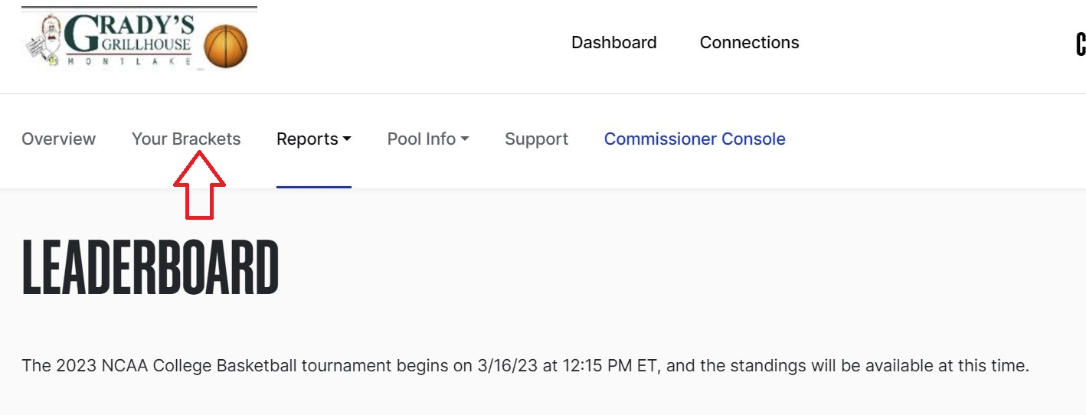

Finally, MAKE YOUR PICKS!! If you would like to enter more than one entry, them selecty CREATE ANOTHER BRACKET ENTRY at bottom.

Good luck…
